沈阳航空航天大学

计算机网络原理
实 验 报 告

实验题目：实验一 组网基础实验
实验二 交换机及虚拟局域网的配置
实验三 网络互连综合实验

院（系）：人工智能学院
专 业：物联网工程
班 级：物联网2202
学 号：223428010210
姓 名：陈梓欣
指导教师：王岩

实验一 组网基础实验

1. 小组成员
小组成员：陈梓欣、明鑫、尹璐、郑羽婷、曲文新。
所属组别：E组。
2. 实验目的
- 熟练掌握双绞线等网络传输媒体的制作、测试技术。
- 熟悉常用网络命令。
- 熟悉主机 1P 地址配置方法。
3．实验内容和步骤
3.1 网线制作
双绞线线序为：橙白，橙，绿白，蓝，蓝白，绿，棕白，棕
制作步骤：
首先剪双绞线，剥皮，排序按 T568B 的顺序，用钳子剪齐，插入水晶头，用专用的钳子压制。制作效果如图1网线制作示例所示。
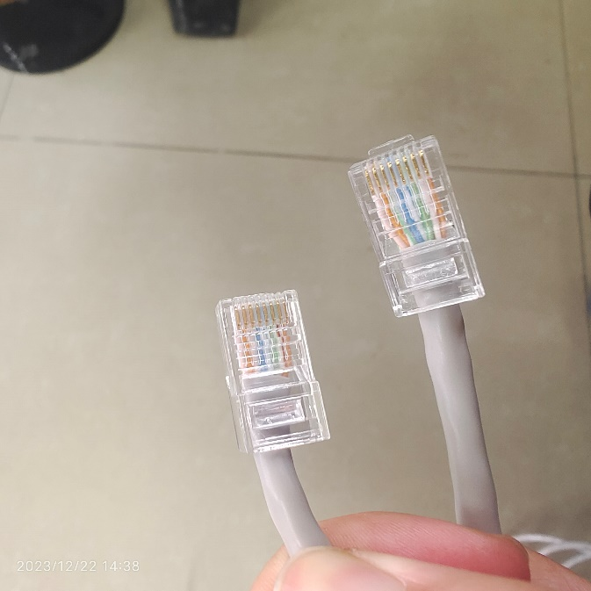
图1.1 网线制作示例
将做好的网线的两头分别插入网线测试仪中，并启动开关，如果两边的指示灯亮起且跑马同步，则表示网线制作成功。测试结果如图2网线可用性测试所示。
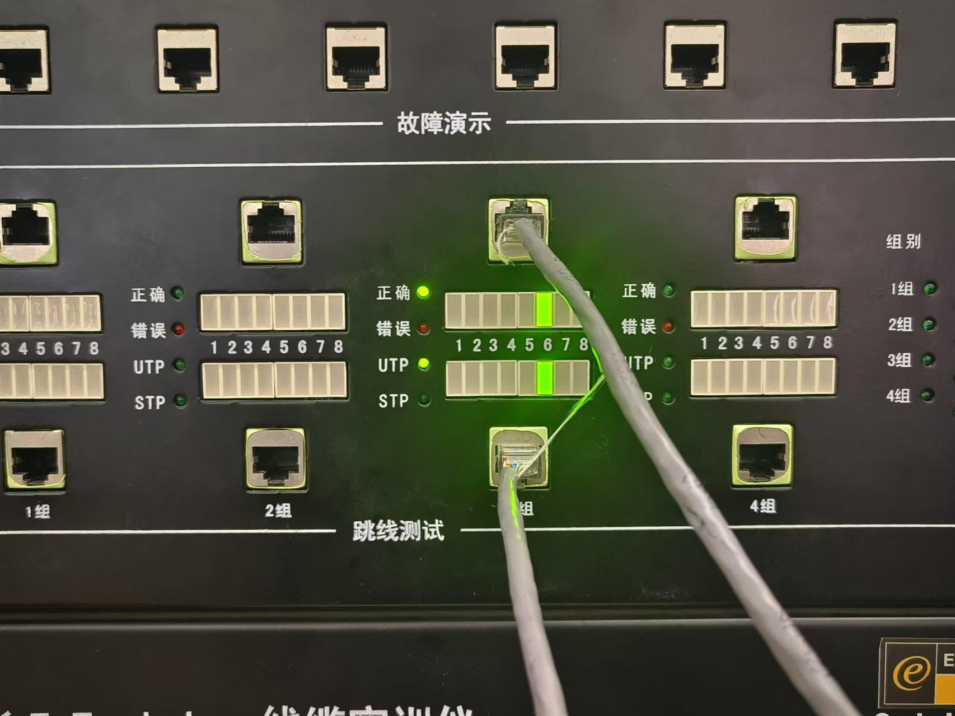
图1.2 网线可用性测试
3.2 常用网络命令的使用
- 写出Ping功能，使用命令并截图。
功能：Ping是一种网络工具，用于测试主机之间的连通性。它发送一个ICMP回显请求到指定的目标主机，并等待接收回显响应。
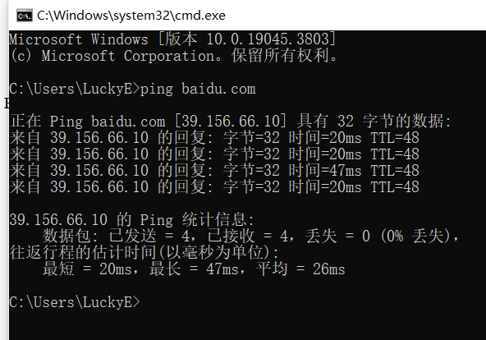
图1.3 ping命令
- 写出ipconfig /all 的功能，使用命令并截图。
功能：显示所有网络接口的详细信息，可以打印有关计算机网络配置的详尽信息，包括网络适配器、IP地址、子网掩码、网关、DNS服务器、物理地址（MAC地址）和其他网络配置信息。
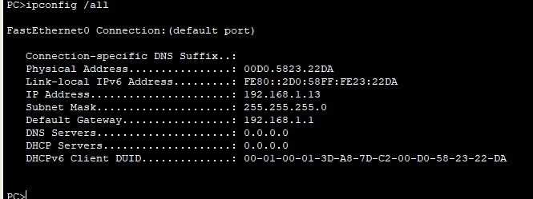
图1.4 ipconfig /all命令
- 写出arp –a的功能，使用命令并截图。
功能：显示已解析的IP地址到MAC地址的映射，列出计算机中ARP缓存中保存的IP地址与MAC地址的映射关系；
显示网络中的设备，展示与计算机相邻连接的其他设备的MAC地址和对应的IP地址；
用于网络排查和故障排除：ARP缓存允许用户查看最近使用过的IP地址和MAC地址的映射，有助于识别网络中设备的连接和通信状态；
提供网络映射信息，能够查看已知设备的MAC地址和IP地址的映射是很有用的，可以检查这些映射是否与预期一致。
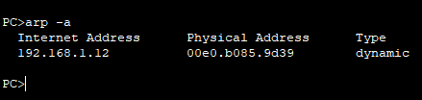
图1.5 arp-a命令
- 写出tracert的功能，使用命令并截图。
功能：追踪数据包的路径，它向目标主机发送数据包，并记录每个节点（路由器或服务器）的响应时间；
显示每个节点的延迟，tracert 显示数据包经过的每个路由器（或主机）的IP地址，并记录到达每个节点所需的时间（以毫秒为单位）；
确定数据包路径，跟踪数据包穿越互联网的路径，有助于了解数据包从源到目的地所经过的网络路径，以及每个节点的响应时间；
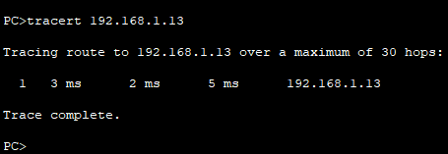
图1.6 tracert命令
3.3 主机IP地址基本配置方法
写出主机IP地址基本配置方法
连接简单局域网并对主机IP地址进行配置为192.168.1.56，对子网掩码配置为255.255.255.0，删掉初始默认网关如图1.7。
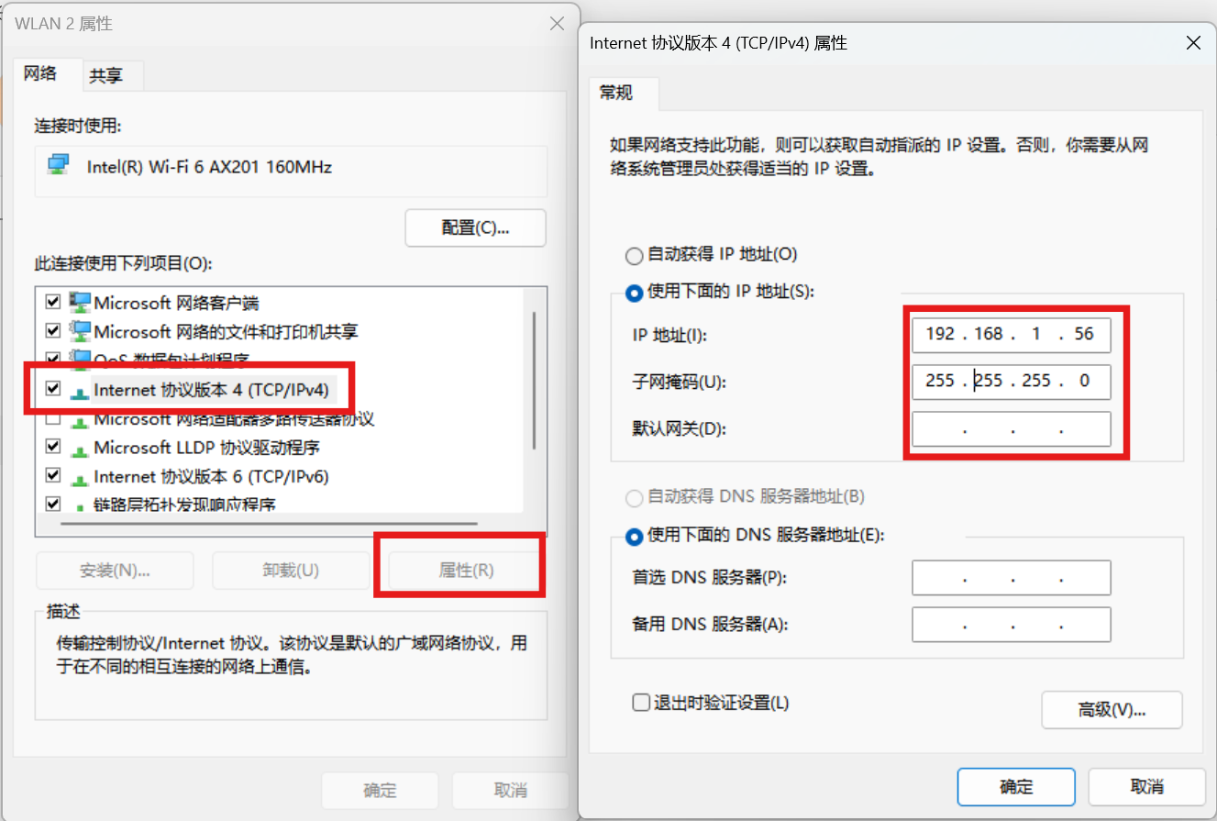
图1.7 主机IP配置示例

实验二 交换机及虚拟局域网的配置
1. 小组成员
小组成员：陈梓欣、明鑫、尹璐、郑羽婷、曲文新。
所属组别：E组。
2. 实验目的
- 掌握交换机各种命令行操作模式的区别，以及各模式间切换方法。
- 学习交换机的管理特性及命令行操作，掌握交换机的基本配置方法。
- 掌握交换机系统和配置信息的查看方法，获取交换机的当前工作状态。
- 掌握交换机VLAN的配置方法。
3．实验内容和步骤
实验2.1
画出所用的网络拓扑结构图。
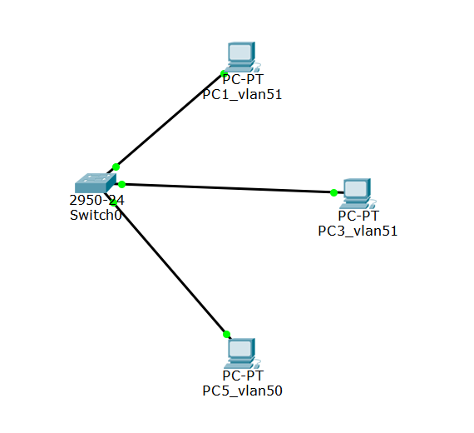
图2.1 交换机VLAN实验拓扑
写出：
- 所有的配置过程。（如实验过程中遇到问题，写出问题原因及解决方法）
- 首先先配置主机IP地址，打开Internet协议版本4的属性，将IP地址改为192.168.1.56，子网掩码为255.255.255.0
- 然后在Web页面的形式登录到系统的控制平台，登陆网址是：http://192.168.1.30:8080。选择你所要操作的硬件设备，点击直接进入其操作界面，按PPT指令开始配置。
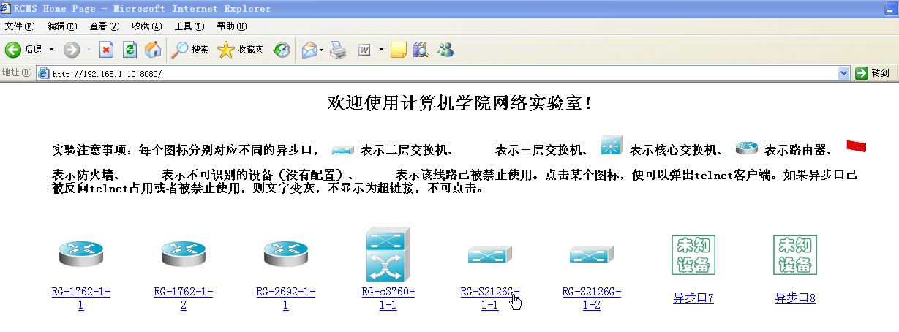
图2.2 系统的控制平台
- 选定设备，进行配置。具体配置指令如下：
建立一个VLAN 51
Switch(config)#vlan 51
Switch(config-vlan)#name vlan51
Switch(config-vlan)#exit
把端口fastethernet 0/1加入进vlan 51
Switch(config)# interface fastethernet 0/1
Switch(config-if)# switchport access vlan 51

把端口fastethernet 0/2加入进vlan 51
Switch(config)# interface fastethernet 0/2
Switch(config-if)# switchport access vlan 51

建立一个VLAN 50
Switch(config)#vlan 50
Switch(config-vlan)#name vlan50
Switch(config-vlan)#exit
把端口fastethernet 0/3加入进vlan 50
Switch(config)# interface fastethernet 0/3
Switch(config-if)# switchport access vlan 50

- 写出配置成功后，每台设备执行“show vlan”和“show running-config”后的结果。
- Switch#show vlan

VLAN Name Status Ports
---- -------------------------------- --------- -------------------------------
1 default active Fa0/4, Fa0/5, Fa0/6, Fa0/7
Fa0/8, Fa0/9, Fa0/10, Fa0/11
Fa0/12, Fa0/13, Fa0/14, Fa0/15
Fa0/16, Fa0/17, Fa0/18, Fa0/19
Fa0/20, Fa0/21, Fa0/22, Fa0/23
Fa0/24
50 vlan50 active Fa0/3
51 vlan51 active Fa0/1, Fa0/2
1002 fddi-default act/unsup
1003 token-ring-default act/unsup
1004 fddinet-default act/unsup
1005 trnet-default act/unsup

VLAN Type SAID MTU Parent RingNo BridgeNo Stp BrdgMode Trans1 Trans2
---- ----- ---------- ----- ------ ------ -------- ---- -------- ------ ------
1 enet 100001 1500 - - - - - 0 0
50 enet 100050 1500 - - - - - 0 0
51 enet 100051 1500 - - - - - 0 0
1002 fddi 101002 1500 - - - - - 0 0
1003 tr 101003 1500 - - - - - 0 0
1004 fdnet 101004 1500 - - - ieee - 0 0
1005 trnet 101005 1500 - - - ibm - 0 0

Remote SPAN VLANs
------------------------------------------------------------------------------

Primary Secondary Type Ports
------- --------- ----------------- ------------------------------------------

- Switch#show running-config
Building configuration...

Current configuration : 1058 bytes
!
version 12.1
no service timestamps log datetime msec
no service timestamps debug datetime msec
no service password-encryption
!
hostname Switch
!
!
!
spanning-tree mode pvst
!
interface FastEthernet0/1
switchport access vlan 51
!
interface FastEthernet0/2
switchport access vlan 51
!
interface FastEthernet0/3
switchport access vlan 50
!
interface FastEthernet0/4
!
interface FastEthernet0/5
!
interface FastEthernet0/6
!
interface FastEthernet0/7
!
interface FastEthernet0/8
!
interface FastEthernet0/9
!
interface FastEthernet0/10
!
interface FastEthernet0/11
!
interface FastEthernet0/12
!
interface FastEthernet0/13
!
interface FastEthernet0/14
!
interface FastEthernet0/15
!
interface FastEthernet0/16
!
interface FastEthernet0/17
!
interface FastEthernet0/18
!
interface FastEthernet0/19
!
interface FastEthernet0/20
!
interface FastEthernet0/21
!
interface FastEthernet0/22
!
interface FastEthernet0/23
!
interface FastEthernet0/24
!
interface Vlan1
no ip address
shutdown
!
!
!
!
line con 0
!
line vty 0 4
login
line vty 5 15
login
!
!
end
- 测试连通性的结果（截图）。
- 网络设备配置好后，对选定的测试主机，禁用“本地连接3”，启用“本地连接4”,并按照实验拓扑图修改1P地址:
表2.1 选定测试机IP及划分VLAN
PC | IP | VLAN
PC1_vlan51 | 192.168.51.1 | VLAN 51
PC3_vlan51 | 192.168.51.3 | VLAN 51
PC5_vlan50 | 192.168.50.5 | VLAN 50

- 通过网络命令进行测试（ping命令）:
- 同一个VLAN内主机的连通性
PC1_vlan51:
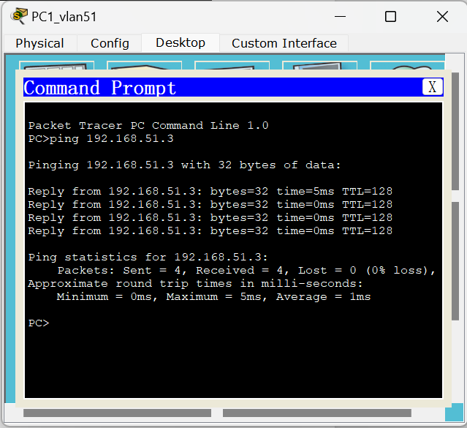
图2.3 PC1_vlan51测试机相同VLAN主机连通性测试
PC3_vlan51:
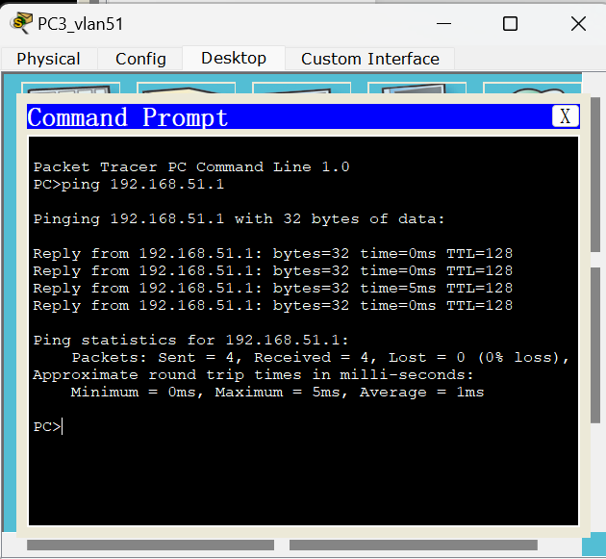
图2.4 PC3_vlan51测试机相同VLAN主机连通性测试
- 不同VLAN主机的连通性
PC1_vlan51:
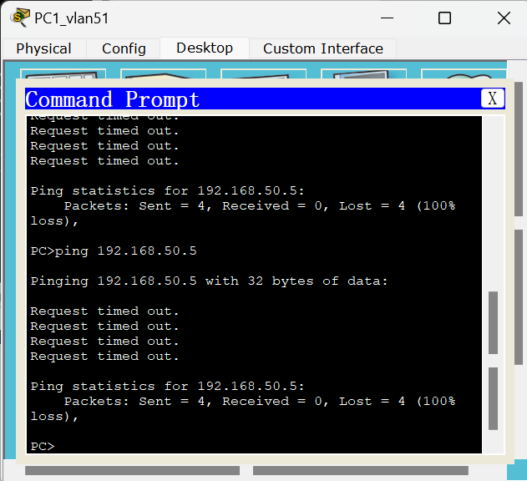
图2.5 PC1_vlan51测试机不同VLAN主机连通性测试
PC3_vlan51:
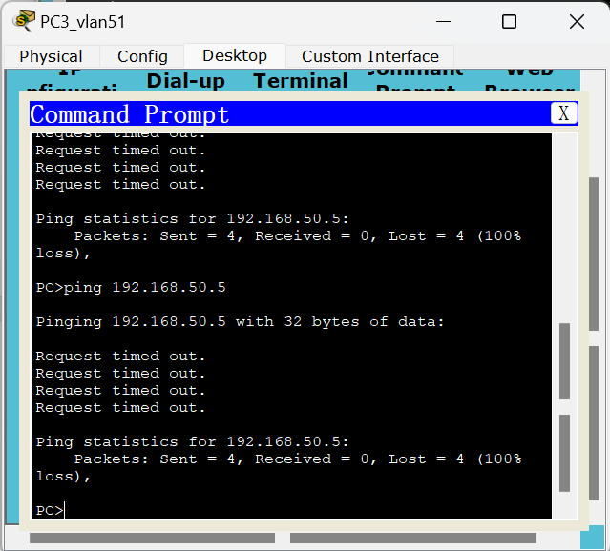
图2.6 PC3_vlan51测试机不同VLAN主机连通性测试
PC5_vlan50:
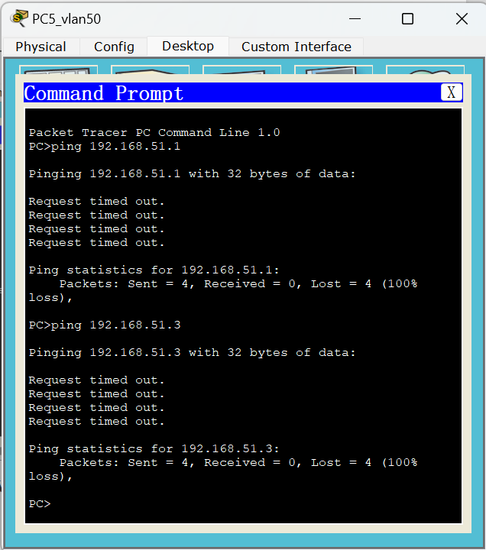
图2.7 PC5_vlan50测试机不同VLAN主机连通性测试
实验2.2
画出所用的网络拓扑结构图。
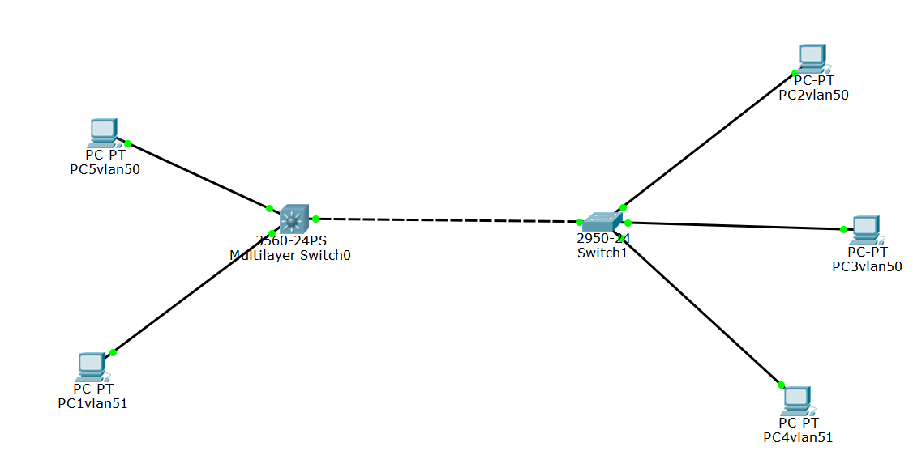
图2.8 跨交换机实现VLAN实验拓扑
写出：
- 所有的配置过程。（如实验过程中遇到问题，写出问题原因及解决方法）
在交换机A上：
switch0>en
switch0#config terminal
Enter configuration commands, one per line. End with CNTL/Z.
修改交换机名称为switchA
switch0(config)#ho switchA

建立一个VLAN 50
switchA(config)#vlan 50
switchA(config-vlan)#na vlan50
把端口fastethernet 0/1加入进vlan 50
switchA(config-vlan)#in fa 0/1
switchA(config-if)#switchport access vlan 50
switchA(config-if)#exit

建立一个VLAN 51
switchA(config)#vlan 51
switchA(config-vlan)#na vlan51
把端口fastethernet 0/2加入进vlan 51
switchA(config-vlan)#in fa 0/2
switchA(config-if)#switchport access vlan 51
switchA(config-if)#exit
switchA(config)#in fa 0/3
switchA(config-if)#exit
switchA(config)#exit

创建虚拟接口vlan 50
switchA(config)#in vlan 50
switchA(config-if)#
%LINK-5-CHANGED: Interface Vlan50, changed state to up

%LINEPROTO-5-UPDOWN: Line protocol on Interface Vlan50, changed state to up
配置虚拟接口vlan 50的IP地址192.168.50.1
switchA(config-if)#ip address 192.168.50.1 255.255.255.0
开启端口
switchA(config-if)#no shutdown
switchA(config-if)#exit
创建虚拟接口vlan 51
switchA(config)#in vlan 51
switchA(config-if)#
%LINK-5-CHANGED: Interface Vlan51, changed state to up

%LINEPROTO-5-UPDOWN: Line protocol on Interface Vlan51, changed state to up
配置虚拟接口vlan 51的IP地址192.168.51.1
switchA(config-if)#ip address 192.168.51.1 255.255.255.0
开启端口
switchA(config-if)#no shutdown
switchA(config-if)#exit

在交换机B上：
switch1#config terminal
Enter configuration commands, one per line. End with CNTL/Z.
修改交换机名称为 switchB
switch1(config)#ho switchB

建立一个VLAN 50
switchB(config)#vlan 50
switchB(config-vlan)#na vlan50
把端口fastethernet 0/2加入进vlan 50
switchB(config-vlan)#in fa 0/2
switchB(config-if)#switchport access vlan 50
把端口fastethernet 0/4加入进vlan 50
switchB(config-vlan)#in fa 0/4
switchB(config-if)#switchport access vlan 50
switchB(config-if)#exit

建立一个VLAN 51
switchB(config)#vlan 51
switchB(config-vlan)#na vlan51
把端口fastethernet 0/1加入进vlan 51
switchB(config-vlan)#in fa 0/1
switchB(config-if)#switchport access vlan 51
switchB(config-if)#exit

把两个交换机相连的端口fastethernet 0/3设置为trunk方式
switchB(config)#in fa 0/3
switchB(config-if)#switchport mode trunk
switchB(config-if)#exit
switchB(config)#exit

创建虚拟接口vlan 50
switchB(config)#in vlan 50
switchB(config-if)#
%LINK-5-CHANGED: Interface Vlan50, changed state to up

%LINEPROTO-5-UPDOWN: Line protocol on Interface Vlan50, changed state to up
配置虚拟接口vlan 50的IP地址192.168.50.2
switchB(config-if)#ip address 192.168.50.2 255.255.255.0
开启端口
switchB(config-if)#no shutdown
switchB(config-if)#exit
创建虚拟接口vlan 51
switchB(config)#in vlan 51
switchB(config-if)#
%LINK-5-CHANGED: Interface Vlan51, changed state to up

%LINEPROTO-5-UPDOWN: Line protocol on Interface Vlan51, changed state to up
配置虚拟接口vlan 50的IP地址192.168.50.2
switchB(config-if)#ip address 192.168.51.2 255.255.255.0
开启端口
switchB(config-if)#no shutdown
switchB(config-if)#exit

- 写出配置成功后，每台设备执行“show running-config”后的结果。
- 交换机A
switchA#show running-config
Building configuration...

Current configuration : 1365 bytes
!
version 12.2
no service timestamps log datetime msec
no service timestamps debug datetime msec
no service password-encryption
!
hostname switchA
!
!
!
!
!
!
!
!
!
!
!
!
!
!
!
!
!
!
!
!
spanning-tree mode pvst
!
!
!
!
!
!
interface FastEthernet0/1
switchport access vlan 50
duplex half
speed 10
!
interface FastEthernet0/2
switchport access vlan 51
duplex half
speed 10
!
interface FastEthernet0/3
duplex half
speed 10
!
interface FastEthernet0/4
!
interface FastEthernet0/5
!
interface FastEthernet0/6
!
interface FastEthernet0/7
!
interface FastEthernet0/8
!
interface FastEthernet0/9
!
interface FastEthernet0/10
!
interface FastEthernet0/11
!
interface FastEthernet0/12
!
interface FastEthernet0/13
!
interface FastEthernet0/14
!
interface FastEthernet0/15
!
interface FastEthernet0/16
!
interface FastEthernet0/17
!
interface FastEthernet0/18
!
interface FastEthernet0/19
!
interface FastEthernet0/20
!
interface FastEthernet0/21
!
interface FastEthernet0/22
!
interface FastEthernet0/23
!
interface FastEthernet0/24
!
interface GigabitEthernet0/1
!
interface GigabitEthernet0/2
!
interface Vlan1
no ip address
shutdown
!
interface Vlan50
ip address 192.168.50.1 255.255.255.0
!
interface Vlan51
ip address 192.168.51.1 255.255.255.0
!
ip classless
!
ip flow-export version 9
!
!
!
!
!
!
!
line con 0
!
line aux 0
!
line vty 0 4
login
!
!
!
end

- 交换机B
switchB#show running-config
Building configuration...

Current configuration : 1290 bytes
!
version 12.1
no service timestamps log datetime msec
no service timestamps debug datetime msec
no service password-encryption
!
hostname switchB
!
!
!
spanning-tree mode pvst
!
interface FastEthernet0/1
switchport access vlan 51
duplex half
speed 10
!
interface FastEthernet0/2
switchport access vlan 50
duplex half
speed 10
!
interface FastEthernet0/3
switchport mode trunk
duplex half
speed 10
!
interface FastEthernet0/4
switchport access vlan 50
duplex half
speed 10
!
interface FastEthernet0/5
!
interface FastEthernet0/6
!
interface FastEthernet0/7
!
interface FastEthernet0/8
!
interface FastEthernet0/9
!
interface FastEthernet0/10
!
interface FastEthernet0/11
!
interface FastEthernet0/12
!
interface FastEthernet0/13
!
interface FastEthernet0/14
!
interface FastEthernet0/15
!
interface FastEthernet0/16
!
interface FastEthernet0/17
!
interface FastEthernet0/18
!
interface FastEthernet0/19
!
interface FastEthernet0/20
!
interface FastEthernet0/21
!
interface FastEthernet0/22
!
interface FastEthernet0/23
!
interface FastEthernet0/24
!
interface Vlan1
no ip address
shutdown
!
interface Vlan50
ip address 192.168.50.2 255.255.255.0
!
interface Vlan51
ip address 192.168.51.2 255.255.255.0
!
!
!
!
line con 0
!
line vty 0 4
login
line vty 5 15
login
!
!
end

- 测试连通性的结果（截图）。
- 网络设备配置好后，对选定的测试主机，禁用“本地连接3”，启用“本地连接4”,并按照实验拓扑图修改1P地址

表2.2 选定测试主机IP、划分VLAN以及连接的交换机与端口
PC | IP | VLAN | Switch | Fastethernet
PC5vlan50 | 192.168.50.5 | VLAN 50 | switchA | Fa 0/1
PC1vlan51 | 192.168.51.11 | VLAN 51 | switchA | Fa 0/2
PC2vlan50 | 192.168.50.22 | VLAN 50 | switchB | Fa 0/2
PC3vlan50 | 192.168.50.3 | VLAN 50 | switchB | Fa 0/4
PC4vlan51 | 192.168.51.4 | VLAN 51 | switchB | Fa 0/1
作为两个交换机相连的端口，将其设置为trunk方式 |  |  |  | Fa 0/3

- 通过网络命令进行测试（ping命令）:
- 不同交换机内同一个VLAN内主机的连通性
PC5vlan50：
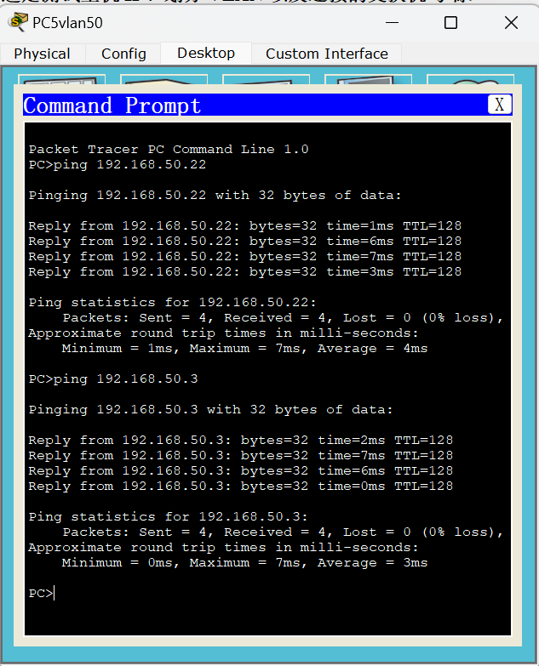
图2.9 PC5vlan50测试机跨交换机相同VLAN主机连通性测试

PC4vlan51：
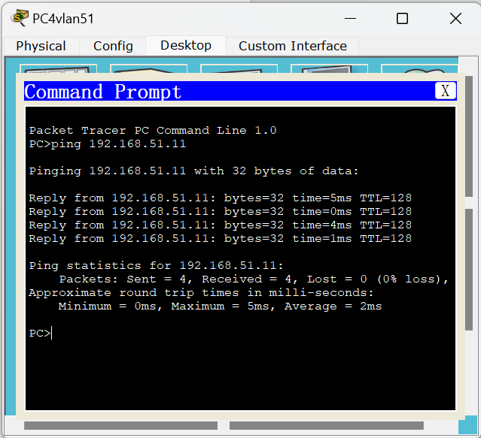
图2.10 PC4vlan51测试机跨交换机相同VLAN主机连通性测试
- 不同交换机内不同VLAN主机的连通性
PC3vlan50：
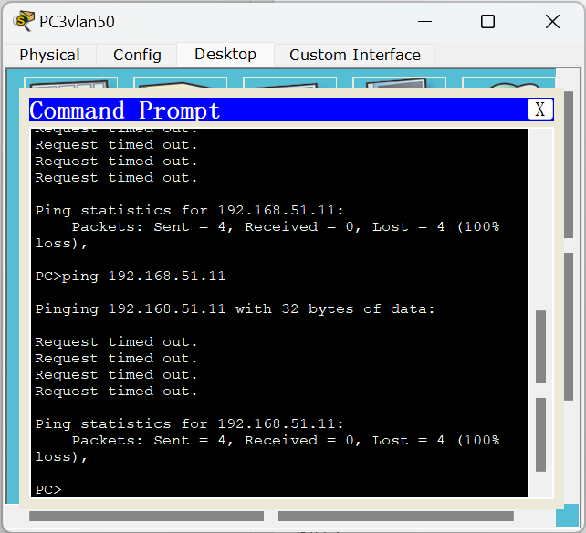
图2.11 PC3vlan50测试机跨交换机不同VLAN主机连通性测试

PC1vlan51：
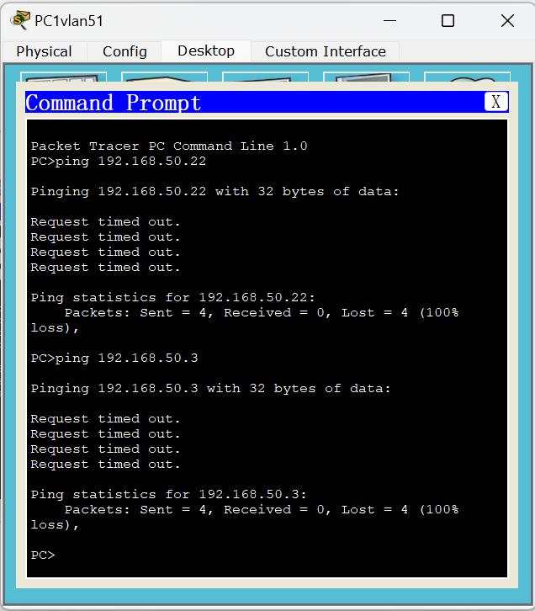
图2.12 PC1vlan51测试机跨交换机不同VLAN主机连通性测试

实验三 网络互连综合实验
1. 小组成员
小组成员：陈梓欣、明鑫、尹璐、郑羽婷、曲文新。
所属组别：E组。
2. 实验目的
- 掌握利用三层交换机实现不同VLAN间通信的方法。
- 掌握路由器基本配置方法。
- 掌握静态路由和动态路由的配置方法。
3．实验内容和步骤
实验3.1
画出所用的网络拓扑结构图。

图3.1 跨交换机实现VLAN实验拓扑
写出：
- 所有的配置过程。（如实验过程中遇到问题，写出问题原因及解决方法）
在三层交换机上：
switch0>en
switch0#config terminal
Enter configuration commands, one per line. End with CNTL/Z.
修改交换机名称为switchA
switch0(config)#ho switchA

建立一个VLAN 50
switchA(config)#vlan 50
switchA(config-vlan)#na vlan50
把端口fastethernet 0/1加入进vlan 50
switchA(config-vlan)#in fa 0/1
switchA(config-if)#switchport access vlan 50
switchA(config-if)#exit

建立一个VLAN 51
switchA(config)#vlan 51
switchA(config-vlan)#na vlan51
把端口fastethernet 0/2加入进vlan 51
switchA(config-vlan)#in fa 0/2
switchA(config-if)#switchport access vlan 51
switchA(config-if)#exit
switchA(config)#in fa 0/3
switchA(config-if)#exit
switchA(config)#exit

创建虚拟接口vlan 50
switchA(config)#in vlan 50
switchA(config-if)#
%LINK-5-CHANGED: Interface Vlan50, changed state to up

%LINEPROTO-5-UPDOWN: Line protocol on Interface Vlan50, changed state to up
配置虚拟接口vlan 50的IP地址192.168.50.1
switchA(config-if)#ip address 192.168.50.1 255.255.255.0
开启端口
switchA(config-if)#no shutdown
switchA(config-if)#exit
创建虚拟接口vlan 51
switchA(config)#in vlan 51
switchA(config-if)#
%LINK-5-CHANGED: Interface Vlan51, changed state to up

%LINEPROTO-5-UPDOWN: Line protocol on Interface Vlan51, changed state to up
配置虚拟接口vlan 51的IP地址192.168.51.1
switchA(config-if)#ip address 192.168.51.1 255.255.255.0
开启端口
switchA(config-if)#no shutdown
switchA(config-if)#exit

在二层交换机上：
switch1#config terminal
Enter configuration commands, one per line. End with CNTL/Z.
修改交换机名称为 switchB
switch1(config)#ho switchB

建立一个VLAN 50
switchB(config)#vlan 50
switchB(config-vlan)#na vlan50
把端口fastethernet 0/2加入进vlan 50
switchB(config-vlan)#in fa 0/2
switchB(config-if)#switchport access vlan 50
把端口fastethernet 0/4加入进vlan 50
switchB(config-vlan)#in fa 0/4
switchB(config-if)#switchport access vlan 50
switchB(config-if)#exit

建立一个VLAN 51
switchB(config)#vlan 51
switchB(config-vlan)#na vlan51
把端口fastethernet 0/1加入进vlan 51
switchB(config-vlan)#in fa 0/1
switchB(config-if)#switchport access vlan 51
switchB(config-if)#exit

把两个交换机相连的端口fastethernet 0/3设置为trunk方式
switchB(config)#in fa 0/3
switchB(config-if)#switchport mode trunk
switchB(config-if)#exit
switchB(config)#exit

创建虚拟接口vlan 50
switchB(config)#in vlan 50
switchB(config-if)#
%LINK-5-CHANGED: Interface Vlan50, changed state to up

%LINEPROTO-5-UPDOWN: Line protocol on Interface Vlan50, changed state to up
配置虚拟接口vlan 50的IP地址192.168.50.2
switchB(config-if)#ip address 192.168.50.2 255.255.255.0
开启端口
switchB(config-if)#no shutdown
switchB(config-if)#exit
创建虚拟接口vlan 51
switchB(config)#in vlan 51
switchB(config-if)#
%LINK-5-CHANGED: Interface Vlan51, changed state to up

%LINEPROTO-5-UPDOWN: Line protocol on Interface Vlan51, changed state to up
配置虚拟接口vlan 50的IP地址192.168.50.2
switchB(config-if)#ip address 192.168.51.2 255.255.255.0
开启端口
switchB(config-if)#no shutdown
switchB(config-if)#exit

- 写出配置成功后，三层交换机执行“show running-config”、“show ip route”和“show ip interface brief”后的结果；二层交换机执行show vlan”、“show running-config”后的结果。
- 对三层交换机（switchA）
- show running-config
switchA#show running-config
Building configuration...

Current configuration : 1365 bytes
!
version 12.2
no service timestamps log datetime msec
no service timestamps debug datetime msec
no service password-encryption
!
hostname switchA
!
!
!
!
!
!
!
!
!
!
!
!
!
!
!
!
!
!
!
!
spanning-tree mode pvst
!
!
!
!
!
!
interface FastEthernet0/1
switchport access vlan 50
duplex half
speed 10
!
interface FastEthernet0/2
switchport access vlan 51
duplex half
speed 10
!
interface FastEthernet0/3
duplex half
speed 10
!
interface FastEthernet0/4
!
interface FastEthernet0/5
!
interface FastEthernet0/6
!
interface FastEthernet0/7
!
interface FastEthernet0/8
!
interface FastEthernet0/9
!
interface FastEthernet0/10
!
interface FastEthernet0/11
!
interface FastEthernet0/12
!
interface FastEthernet0/13
!
interface FastEthernet0/14
!
interface FastEthernet0/15
!
interface FastEthernet0/16
!
interface FastEthernet0/17
!
interface FastEthernet0/18
!
interface FastEthernet0/19
!
interface FastEthernet0/20
!
interface FastEthernet0/21
!
interface FastEthernet0/22
!
interface FastEthernet0/23
!
interface FastEthernet0/24
!
interface GigabitEthernet0/1
!
interface GigabitEthernet0/2
!
interface Vlan1
no ip address
shutdown
!
interface Vlan50
ip address 192.168.50.1 255.255.255.0
!
interface Vlan51
ip address 192.168.51.1 255.255.255.0
!
ip classless
!
ip flow-export version 9
!
!
!
!
!
!
!
line con 0
!
line aux 0
!
line vty 0 4
login
!
!
!
End
- show ip route
switchA#show ip route
Codes: C - connected, S - static, I - IGRP, R - RIP, M - mobile, B - BGP
D - EIGRP, EX - EIGRP external, O - OSPF, IA - OSPF inter area
N1 - OSPF NSSA external type 1, N2 - OSPF NSSA external type 2
E1 - OSPF external type 1, E2 - OSPF external type 2, E - EGP
i - IS-IS, L1 - IS-IS level-1, L2 - IS-IS level-2, ia - IS-IS inter area
* - candidate default, U - per-user static route, o - ODR
P - periodic downloaded static route

Gateway of last resort is not set

C 192.168.50.1/24 is directly connected, Vlan50
C 192.168.51.1/24 is directly connected, Vlan51
- show ip interface brief
switchA#show ip interface brief
Interface IP-Address OK? Method Status Protocol
FastEthernet0/1 unassigned YES unset up up
FastEthernet0/2 unassigned YES unset up up
FastEthernet0/3 unassigned YES unset up up
FastEthernet0/4 unassigned YES unset down down
FastEthernet0/5 unassigned YES unset down down
FastEthernet0/6 unassigned YES unset down down
FastEthernet0/7 unassigned YES unset down down
FastEthernet0/8 unassigned YES unset down down
FastEthernet0/9 unassigned YES unset down down
FastEthernet0/10 unassigned YES unset down down
FastEthernet0/11 unassigned YES unset down down
FastEthernet0/12 unassigned YES unset down down
FastEthernet0/13 unassigned YES unset down down
FastEthernet0/14 unassigned YES unset down down
FastEthernet0/15 unassigned YES unset down down
FastEthernet0/16 unassigned YES unset down down
FastEthernet0/17 unassigned YES unset down down
FastEthernet0/18 unassigned YES unset down down
FastEthernet0/19 unassigned YES unset down down
FastEthernet0/20 unassigned YES unset down down
FastEthernet0/21 unassigned YES unset down down
FastEthernet0/22 unassigned YES unset down down
FastEthernet0/23 unassigned YES unset down down
FastEthernet0/24 unassigned YES unset down down
GigabitEthernet0/1 unassigned YES unset down down
GigabitEthernet0/2 unassigned YES unset down down
Vlan1 unassigned YES unset administratively down down
Vlan50 192.168.50.1 YES manual up up
Vlan51 192.168.51.1 YES manual up up
- 对二层交换机（switchB）
- show running-config
switchB#show running-config
Building configuration...

Current configuration : 1290 bytes
!
version 12.1
no service timestamps log datetime msec
no service timestamps debug datetime msec
no service password-encryption
!
hostname switchB
!
!
!
spanning-tree mode pvst
!
interface FastEthernet0/1
switchport access vlan 51
duplex half
speed 10
!
interface FastEthernet0/2
switchport access vlan 50
duplex half
speed 10
!
interface FastEthernet0/3
switchport mode trunk
duplex half
speed 10
!
interface FastEthernet0/4
switchport access vlan 50
duplex half
speed 10
!
interface FastEthernet0/5
!
interface FastEthernet0/6
!
interface FastEthernet0/7
!
interface FastEthernet0/8
!
interface FastEthernet0/9
!
interface FastEthernet0/10
!
interface FastEthernet0/11
!
interface FastEthernet0/12
!
interface FastEthernet0/13
!
interface FastEthernet0/14
!
interface FastEthernet0/15
!
interface FastEthernet0/16
!
interface FastEthernet0/17
!
interface FastEthernet0/18
!
interface FastEthernet0/19
!
interface FastEthernet0/20
!
interface FastEthernet0/21
!
interface FastEthernet0/22
!
interface FastEthernet0/23
!
interface FastEthernet0/24
!
interface Vlan1
no ip address
shutdown
!
interface Vlan50
ip address 192.168.50.2 255.255.255.0
!
interface Vlan51
ip address 192.168.51.2 255.255.255.0
!
!
!
!
line con 0
!
line vty 0 4
login
line vty 5 15
login
!
!
end
- show vlan
switchB#show vlan

VLAN Name Status Ports
---- -------------------------------- --------- -------------------------------
1 default active Fa0/5, Fa0/6, Fa0/7, Fa0/8
Fa0/9, Fa0/10, Fa0/11, Fa0/12
Fa0/13, Fa0/14, Fa0/15, Fa0/16
Fa0/17, Fa0/18, Fa0/19, Fa0/20
Fa0/21, Fa0/22, Fa0/23, Fa0/24
50 vlan50 active Fa0/2, Fa0/4
51 vlan51 active Fa0/1
1002 fddi-default act/unsup
1003 token-ring-default act/unsup
1004 fddinet-default act/unsup
1005 trnet-default act/unsup

VLAN Type SAID MTU Parent RingNo BridgeNo Stp BrdgMode Trans1 Trans2
---- ----- ---------- ----- ------ ------ -------- ---- -------- ------ ------
1 enet 100001 1500 - - - - - 0 0
50 enet 100050 1500 - - - - - 0 0
51 enet 100051 1500 - - - - - 0 0
1002 fddi 101002 1500 - - - - - 0 0
1003 tr 101003 1500 - - - - - 0 0
1004 fdnet 101004 1500 - - - ieee - 0 0
1005 trnet 101005 1500 - - - ibm - 0 0

Remote SPAN VLANs
------------------------------------------------------------------------------

Primary Secondary Type Ports
------- --------- ----------------- ------------------------------------------
- show ip interface brief
switchB#show ip interface brief
Interface IP-Address OK? Method Status Protocol
FastEthernet0/1 unassigned YES manual up up
FastEthernet0/2 unassigned YES manual up up
FastEthernet0/3 unassigned YES manual up up
FastEthernet0/4 unassigned YES manual up up
FastEthernet0/5 unassigned YES manual down down
FastEthernet0/6 unassigned YES manual down down
FastEthernet0/7 unassigned YES manual down down
FastEthernet0/8 unassigned YES manual down down
FastEthernet0/9 unassigned YES manual down down
FastEthernet0/10 unassigned YES manual down down
FastEthernet0/11 unassigned YES manual down down
FastEthernet0/12 unassigned YES manual down down
FastEthernet0/13 unassigned YES manual down down
FastEthernet0/14 unassigned YES manual down down
FastEthernet0/15 unassigned YES manual down down
FastEthernet0/16 unassigned YES manual down down
FastEthernet0/17 unassigned YES manual down down
FastEthernet0/18 unassigned YES manual down down
FastEthernet0/19 unassigned YES manual down down
FastEthernet0/20 unassigned YES manual down down
FastEthernet0/21 unassigned YES manual down down
FastEthernet0/22 unassigned YES manual down down
FastEthernet0/23 unassigned YES manual down down
FastEthernet0/24 unassigned YES manual down down
Vlan1 unassigned YES manual administratively down down
Vlan50 192.168.50.2 YES manual up up
Vlan51 192.168.51.2 YES manual up up

- 测试连通性的结果（截图）。
- 网络设备配置好后，对选定的测试主机，禁用“本地连接3”，启用“本地连接4”,并按照实验拓扑图修改1P地址
表3.1 选定测试主机IP、划分VLAN以及连接的交换机与端口
（switchA为三层交换机，switchB为二层交换机）
PC | IP | VLAN | Switch | Fastethernet
PC5vlan50 | 192.168.50.5 | VLAN 50 | switchA | Fa 0/1
PC1vlan51 | 192.168.51.11 | VLAN 51 | switchA | Fa 0/2
PC2vlan50 | 192.168.50.22 | VLAN 50 | switchB | Fa 0/2
PC3vlan50 | 192.168.50.3 | VLAN 50 | switchB | Fa 0/4
PC4vlan51 | 192.168.51.4 | VLAN 51 | switchB | Fa 0/1
作为两个交换机相连的端口，将其设置为trunk方式 |  |  |  | Fa 0/3

- 通过网络命令进行测试（ping命令）:
- 不同交换机内同一个VLAN内主机的连通性
PC4vlan51：

图3.2 PC4vlan51测试机跨交换机相同VLAN主机连通性测试

PC5vlan50：

图3.3 PC5vlan50测试机跨交换机相同VLAN主机连通性测试
- 不同交换机内不同VLAN主机的连通性
PC3vlan50：

图3.4 PC3vlan50测试机跨交换机不同VLAN主机连通性测试
PC1vlan51：

图3.5 PC1vlan51测试机跨交换机不同VLAN主机连通性测试

实验3.2
画出所用的网络拓扑结构图。
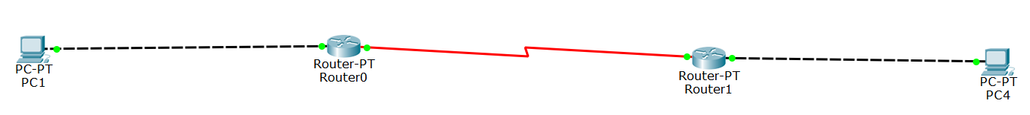
图3.6 静态路由实验拓扑
写出：
- 所有的配置过程。（如实验过程中遇到问题，写出问题原因及解决方法）
路由器A：
配置端口IP地址
Router0(config)#interface fa 0/0
Router0config-if)#ip address 172.16.50.254 255.255.0.0
开启该端口，使端口转发数据
Router0(config-if)#no shutdown

配置DCE端
Router0(config)#interface serial 2/0
Router0(config-if)#ip address 10.10.50.1 255.0.0.0
Router0(config-if)#clock rate 64000
//在DCE端配置时钟频率64000
Router0(config-if)#no shutdown

路由器B：
配置端口IP地址
Router1(config)#interface fa 1/0
Router1(config-if)#ip address 172.31.50.2 255.255.255.0
开启该端口，使端口转发数据
Router1(config-if)#no shutdown

配置DTE端
Router1(config)#interface serial 2/0
Router1(config-if)#ip address 10.10.50.2 255.0.0.0
Router1(config-if)#no shutdown

- 写出配置成功后，每台设备执行“show running-config”、“show ip route”和“show ip interface brief”后的结果。
- 路由器A
- show running-config
Router0#show running-config
Building configuration...

Current configuration : 788 bytes
!
version 12.2
no service timestamps log datetime msec
no service timestamps debug datetime msec
no service password-encryption
!
hostname Router0
!
!
!
!
!
!
!
!
ip cef
no ipv6 cef
!
!
!
!
!
!
!
!
!
!
!
!
!
!
!
!
!
!
interface FastEthernet0/0
ip address 172.16.50.254 255.255.0.0
duplex auto
speed auto
!
interface FastEthernet1/0
no ip address
duplex auto
speed auto
shutdown
!
interface Serial2/0
ip address 10.10.50.1 255.0.0.0
clock rate 64000
!
interface Serial3/0
no ip address
clock rate 2000000
shutdown
!
interface FastEthernet4/0
no ip address
shutdown
!
interface FastEthernet5/0
no ip address
shutdown
!
ip classless
ip route 172.31.0.0 255.255.0.0 10.10.50.2
!
ip flow-export version 9
!
!
!
!
!
!
!
line con 0
!
line aux 0
!
line vty 0 4
login
!
!
!
end

- show ip route
Router0#show ip route
Codes: C - connected, S - static, I - IGRP, R - RIP, M - mobile, B - BGP
D - EIGRP, EX - EIGRP external, O - OSPF, IA - OSPF inter area
N1 - OSPF NSSA external type 1, N2 - OSPF NSSA external type 2
E1 - OSPF external type 1, E2 - OSPF external type 2, E - EGP
i - IS-IS, L1 - IS-IS level-1, L2 - IS-IS level-2, ia - IS-IS inter area
* - candidate default, U - per-user static route, o - ODR
P - periodic downloaded static route

Gateway of last resort is not set

C 10.0.0.0/8 is directly connected, Serial2/0
C 172.16.0.0/16 is directly connected, FastEthernet0/0
S 172.31.0.0/16 [1/0] via 10.10.50.2

- show ip interface brief
Router0#show ip interface brief
Interface IP-Address OK? Method Status Protocol
FastEthernet0/0 172.16.50.254 YES manual up up
FastEthernet1/0 unassigned YES unset administratively down down
Serial2/0 10.10.50.1 YES manual up up
Serial3/0 unassigned YES unset administratively down down
FastEthernet4/0 unassigned YES unset administratively down down
FastEthernet5/0 unassigned YES unset administratively down down

- 路由器B
- show running-config
Router1#show running-config
Building configuration...

Current configuration : 770 bytes
!
version 12.2
no service timestamps log datetime msec
no service timestamps debug datetime msec
no service password-encryption
!
hostname Router1
!
!
!
!
!
!
!
!
ip cef
no ipv6 cef
!
!
!
!
!
!
!
!
!
!
!
!
!
!
!
!
!
!
interface FastEthernet0/0
no ip address
duplex auto
speed auto
shutdown
!
interface FastEthernet1/0
ip address 172.31.50.254 255.255.0.0
duplex auto
speed auto
!
interface Serial2/0
ip address 10.10.50.2 255.0.0.0
!
interface Serial3/0
no ip address
clock rate 2000000
shutdown
!
interface FastEthernet4/0
no ip address
shutdown
!
interface FastEthernet5/0
no ip address
shutdown
!
ip classless
ip route 172.16.0.0 255.255.0.0 10.10.50.1
!
ip flow-export version 9
!
!
!
!
!
!
!
line con 0
!
line aux 0
!
line vty 0 4
login
!
!
!
end

- show ip route
Router1#show ip route
Codes: C - connected, S - static, I - IGRP, R - RIP, M - mobile, B - BGP
D - EIGRP, EX - EIGRP external, O - OSPF, IA - OSPF inter area
N1 - OSPF NSSA external type 1, N2 - OSPF NSSA external type 2
E1 - OSPF external type 1, E2 - OSPF external type 2, E - EGP
i - IS-IS, L1 - IS-IS level-1, L2 - IS-IS level-2, ia - IS-IS inter area
* - candidate default, U - per-user static route, o - ODR
P - periodic downloaded static route

Gateway of last resort is not set

C 10.0.0.0/8 is directly connected, Serial2/0
S 172.16.0.0/16 [1/0] via 10.10.50.1
C 172.31.0.0/16 is directly connected, FastEthernet1/0

- show ip interface brief
Router1#show ip interface brief
Interface IP-Address OK? Method Status Protocol
FastEthernet0/0 unassigned YES unset administratively down down
FastEthernet1/0 172.31.50.254 YES manual up up
Serial2/0 10.10.50.2 YES manual up up
Serial3/0 unassigned YES unset administratively down down
FastEthernet4/0 unassigned YES unset administratively down down
FastEthernet5/0 unassigned YES unset administratively down down

- 测试连通性的结果（截图）。
- 对选定的测试主机，禁用“本地连接3”，启用“本地连接4”,并按照实验拓扑图修改1P地址
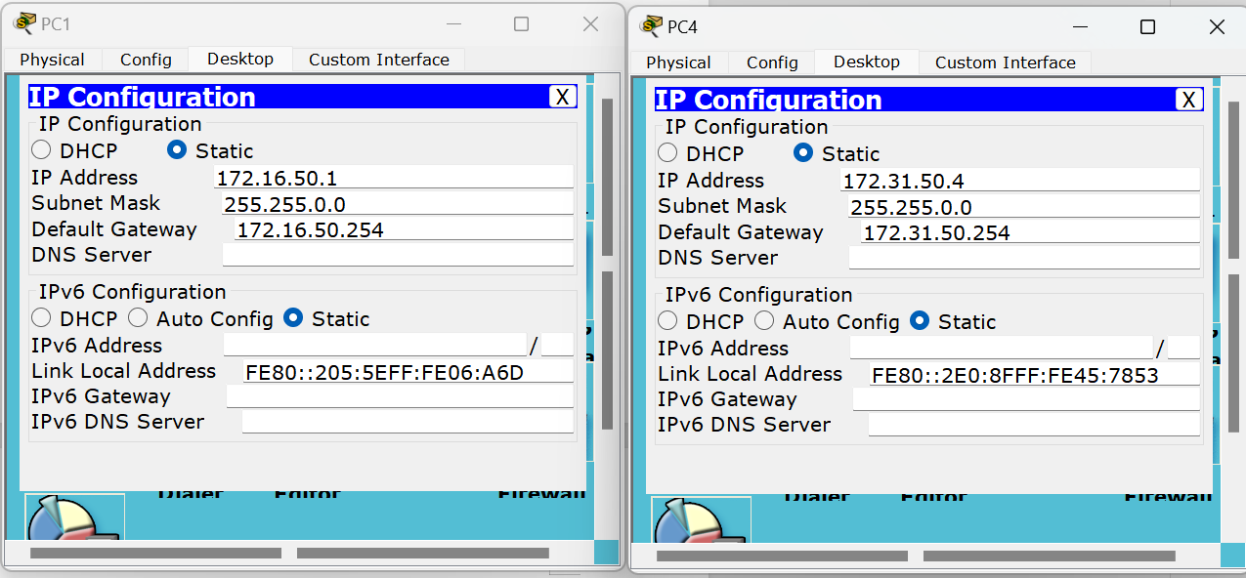
图3.7 测试主机IP、子网掩码、网关修改示意
- 通过网络命令进行测试（ping命令）
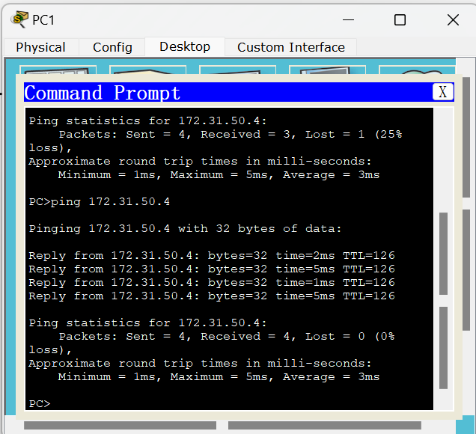
图3.8 不同路由测试机在静态路由条件下连通性测试

实验3.3
画出所用的网络拓扑结构图。
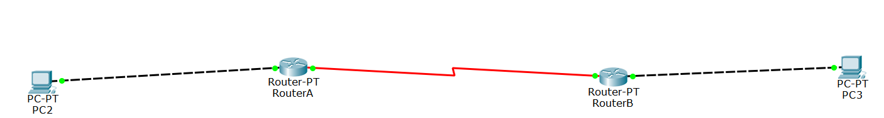
图3.9 RIP路由实验拓扑
写出：
- 所有的配置过程。（如实验过程中遇到问题，写出问题原因及解决方法）
RouterA
配置端口IP
Router(config)#ho RouterA
RouterA(config)#
RouterA(config)#int fa 0/0
RouterA(config-if)#ip add 172.16.51.254 255.255.0.0
RouterA(config-if)#no sh

RouterA(config-if)#

配置DCE端
RouterA(config-if)#int sa 3/0
RouterA(config-if)#ip add 10.10.51.1 255.0.0.0
RouterA(config-if)#clock rate 64000
//在DCE端配置时钟频率64000
RouterA(config-if)#no sh

RouterB配置端口IP
Router#conf t
Enter configuration commands, one per line. End with CNTL/Z.

Router(config-if)#ho RouterB
RouterB(config)#

RouterB(config)#
RouterB(config)#in fa 1/0
RouterB(config-if)#ip add 172.31.51.254 255.255.0.0
RouterB(config-if)#no sh

RouterB(config-if)#
%LINK-5-CHANGED: Interface GigabitEthernet0/1, changed state to up

%LINEPROTO-5-UPDOWN: Line protocol on Interface GigabitEthernet0/1, changed state to up

RouterB(config-if)#ex
配置DTE端
RouterB(config)#int sa 3/0
RouterB(config-if)#ip add 10.10.51.2 255.0.0.0
RouterB(config-if)#no sh

配置RIP协议
RouterA(config)#route rip #开启RIP协议
RouterA(config-router)#version 2 #启用RIPv2
RouterA(config-router)#network 172.16.51.254 #宣告网段
RouterA(config-router)#network 10.10.51.1 #宣告网段
RouterA(config-router)#no auto-summary #关闭自动汇总

RouterB(config)#route rip
RouterB(config-router)#v 2
RouterB(config-router)#network 172.31.51.254
RouterB(config-router)#network 10.10.51.2
RouterB(config-router)#no auto-summary

- 写出配置成功后，每台设备执行“show running-config”、“show ip route”和“show ip interface brief”后的结果。
- RouterA路由
- show running-config
RouterA#show running-config
Building configuration...

Current configuration : 823 bytes
!
version 12.2
no service timestamps log datetime msec
no service timestamps debug datetime msec
no service password-encryption
!
hostname RouterA
!
!
!
!
!
!
!
!
ip cef
no ipv6 cef
!
!
!
!
!
!
!
!
!
!
!
!
!
!
!
!
!
!
interface FastEthernet0/0
ip address 172.16.51.254 255.255.0.0
duplex auto
speed auto
!
interface FastEthernet1/0
no ip address
duplex auto
speed auto
shutdown
!
interface Serial2/0
no ip address
clock rate 2000000
shutdown
!
interface Serial3/0
ip address 10.10.51.1 255.0.0.0
clock rate 64000
!
interface FastEthernet4/0
no ip address
shutdown
!
interface FastEthernet5/0
no ip address
shutdown
!
router rip
version 2
network 10.0.0.0
network 172.16.0.0
no auto-summary
!
ip classless
!
ip flow-export version 9
!
!
!
!
!
!
!
line con 0
!
line aux 0
!
line vty 0 4
login
!
!
!
end

- show ip route
RouterA#show ip route
Codes: C - connected, S - static, I - IGRP, R - RIP, M - mobile, B - BGP
D - EIGRP, EX - EIGRP external, O - OSPF, IA - OSPF inter area
N1 - OSPF NSSA external type 1, N2 - OSPF NSSA external type 2
E1 - OSPF external type 1, E2 - OSPF external type 2, E - EGP
i - IS-IS, L1 - IS-IS level-1, L2 - IS-IS level-2, ia - IS-IS inter area
* - candidate default, U - per-user static route, o - ODR
P - periodic downloaded static route

Gateway of last resort is not set

C 10.0.0.0/8 is directly connected, Serial3/0
C 172.16.0.0/16 is directly connected, FastEthernet0/0
R 172.31.0.0/16 [120/1] via 10.10.51.2, 00:00:24, Serial3/0

- show ip interface brief
RouterA#show ip interface brief
Interface IP-Address OK? Method Status Protocol
FastEthernet0/0 172.16.51.254 YES manual up up
FastEthernet1/0 unassigned YES unset administratively down down
Serial2/0 unassigned YES unset administratively down down
Serial3/0 10.10.51.1 YES manual up up
FastEthernet4/0 unassigned YES unset administratively down down
FastEthernet5/0 unassigned YES unset administratively down down

- RouterB路由
- show running-config
RouterB#show running-config
Building configuration...

Current configuration : 805 bytes
!
version 12.2
no service timestamps log datetime msec
no service timestamps debug datetime msec
no service password-encryption
!
hostname RouterB
!
!
!
!
!
!
!
!
ip cef
no ipv6 cef
!
!
!
!
!
!
!
!
!
!
!
!
!
!
!
!
!
!
interface FastEthernet0/0
no ip address
duplex auto
speed auto
shutdown
!
interface FastEthernet1/0
ip address 172.31.51.254 255.255.0.0
duplex auto
speed auto
!
interface Serial2/0
no ip address
clock rate 2000000
shutdown
!
interface Serial3/0
ip address 10.10.51.2 255.0.0.0
!
interface FastEthernet4/0
no ip address
shutdown
!
interface FastEthernet5/0
no ip address
shutdown
!
router rip
version 2
network 10.0.0.0
network 172.31.0.0
no auto-summary
!
ip classless
!
ip flow-export version 9
!
!
!
!
!
!
!
line con 0
!
line aux 0
!
line vty 0 4
login
!
!
!
end

- show ip route
RouterB#show ip route
Codes: C - connected, S - static, I - IGRP, R - RIP, M - mobile, B - BGP
D - EIGRP, EX - EIGRP external, O - OSPF, IA - OSPF inter area
N1 - OSPF NSSA external type 1, N2 - OSPF NSSA external type 2
E1 - OSPF external type 1, E2 - OSPF external type 2, E - EGP
i - IS-IS, L1 - IS-IS level-1, L2 - IS-IS level-2, ia - IS-IS inter area
* - candidate default, U - per-user static route, o - ODR
P - periodic downloaded static route

Gateway of last resort is not set

C 10.0.0.0/8 is directly connected, Serial3/0
R 172.16.0.0/16 [120/1] via 10.10.51.1, 00:00:26, Serial3/0
C 172.31.0.0/16 is directly connected, FastEthernet1/0

- show ip interface brief
RouterB#show ip interface brief
Interface IP-Address OK? Method Status Protocol
FastEthernet0/0 unassigned YES unset administratively down down
FastEthernet1/0 172.31.51.254 YES manual up up
Serial2/0 unassigned YES unset administratively down down
Serial3/0 10.10.51.2 YES manual up up
FastEthernet4/0 unassigned YES unset administratively down down
FastEthernet5/0 unassigned YES unset administratively down down

- 测试连通性的结果（截图）。
- 对选定的测试主机，禁用“本地连接3”，启用“本地连接4”,并按照实验拓扑图修改1P地址
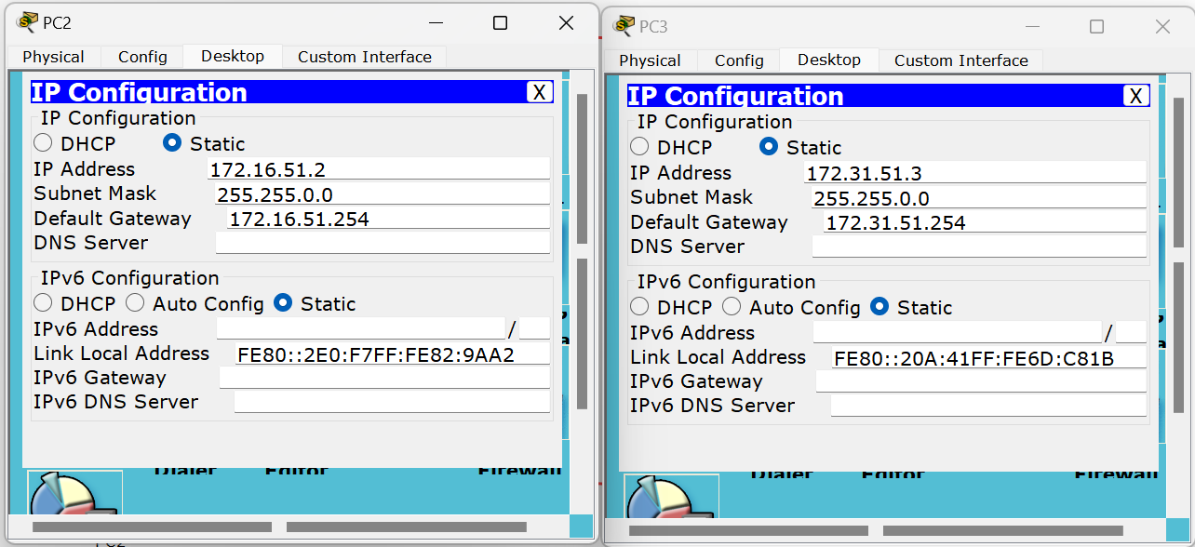
图3.10 测试主机IP、子网掩码、网关修改示意
- 通过网络命令进行测试（ping命令）
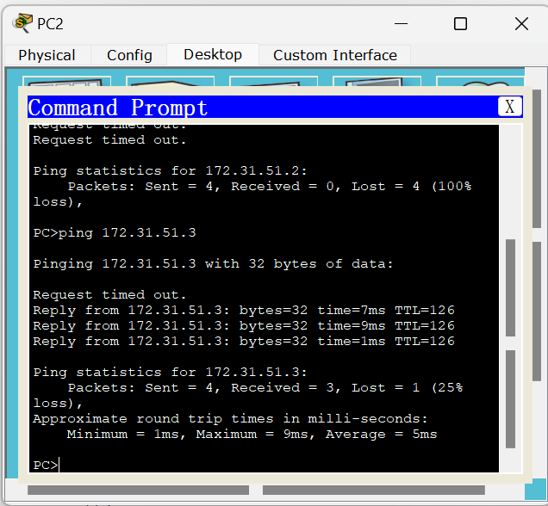
图3.11 不同路由测试机在RIP路由条件下连通性测试

